Exercise 3-1 Concolution and Fractionally Strides Convolution

Jirayu Petchhan, D10907801

Real image and transform to 112x112 pixel

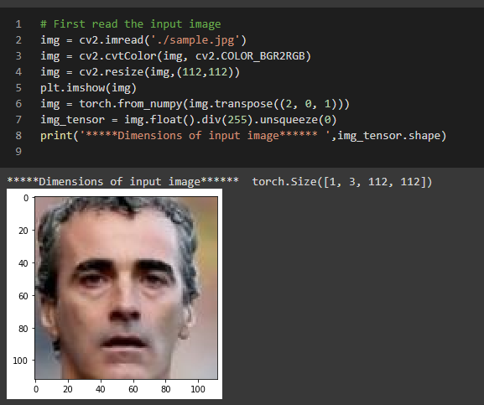

**Convolution (the same size at 55 x 55 x 3)**

When changing to kernel size = ½ (bigger than default at 1/9).

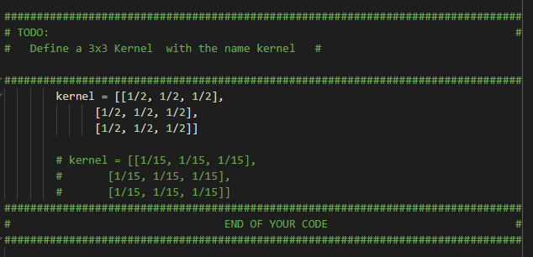

Result

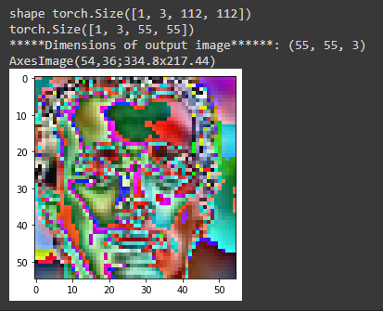

The bigger value of filter_size might cause of distorted color when convoluting.

When changing to kernel size = 1/15 (less than default value of filter_size at 1/9).

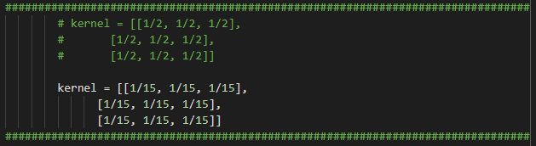

Result

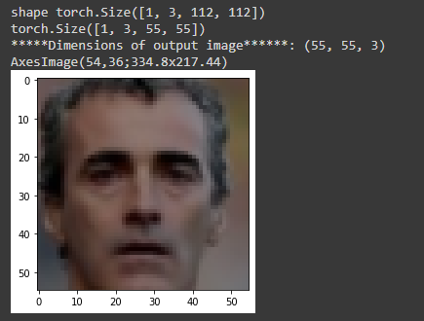

Image had occurred in the same size when convoluting but the amount of filter_size is less than default value (i.e. 1/15 < 1/9) that make an effective distribution of kernel when compressed.

**Deconvolution (back to the same size of real image at 112 x 112 x 3)**

**Note continuing from changing kernel_size to 1/15 i.e. less than default value)**

When changing to kernel size = ½ (bigger than default at 1/9)

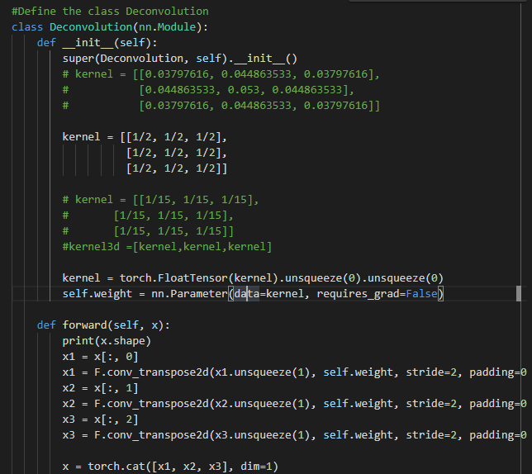

Result

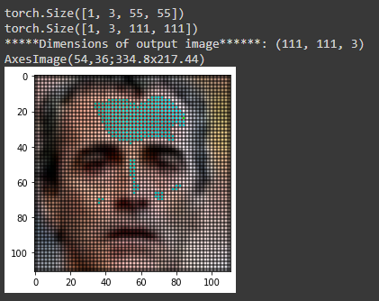

The result show that the image is set kernel_size of deconvolution less than default value of 1/9) (lighter than reconstructed image)

When changing to kernel size = 1/15 (less than default value of filter_size at 1/9).

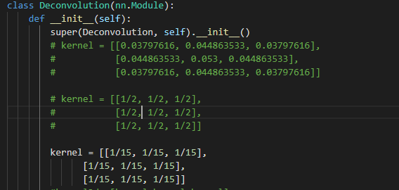

Result

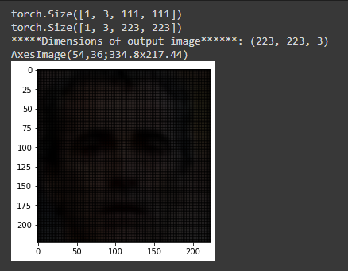

The result show that the image is useful of arbitrary strides that will transposed convolute (deconv) back the high-resolution as real images when set the kernel_size much smaller. (the gap of reconstruction from fractionally strides cause to be dark image)

As we see in the below reconstructed image when changing in grayscale and comparation of the filter have been deconvolution back to 112x112 with 4x4 filter_size. (This below one there are the black gap after fractionally striding).

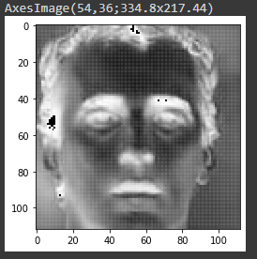

**Changing the filter_size from 3x3(1/9 all filter point) to 4x4 (1/16 all filter point)**

**Both convolution and decovlution**

Deconvolution with 4x4 kernel_size

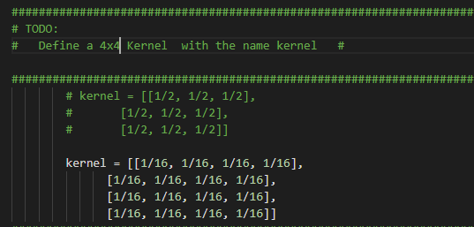

The result of convolution

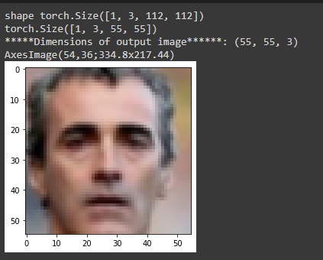

Deconvolution with 4x4 kernel_size

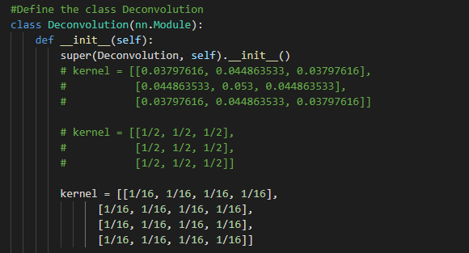

The result of deconvolution

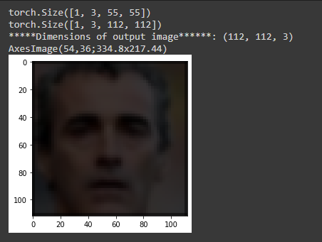

The result show that when we add the kernel size from 3x3 to 4x4 for deconvolution

The reconstructed image will be fulfill more than 3x3 kernel_size

Higher resolution of reconstructed image when fractionally striding than 3x3 filter_size.

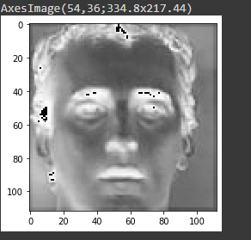

**Implement more than 1 convolution**

I add another one (conv4) with indexing from channel 2nd index (the same as x3)

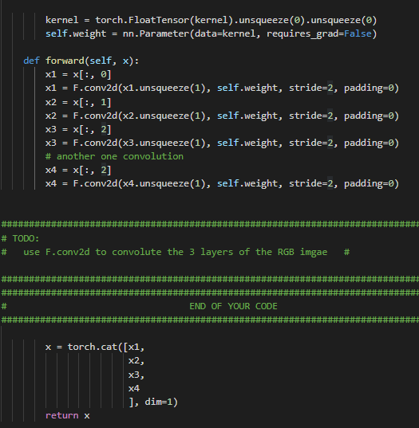

The result of 4 convolutions (that mean 4 channels for the final to compress image).

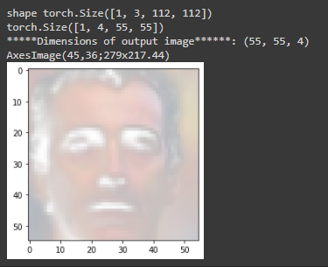

Compare with 3 conv for each channel (RGB)



We will see that the brightness is harder than 3 conv because we implement 2 conv for channel index at 2. So, the encoding of feature in this channel much more following that means double feature encoded.